To: | Cabinet
Date: | 22 October 2025
Report of: | Clive Tritton, Director of Economy, Regeneration and Sustainability
Title of Report: | Project approvals and delegations for the Westlands Drive/ Halliday Hill affordable housing development

Summary and recommendations
Decision being taken: | This report seeks project approval and delegations to progress the development of affordable homes at Westlands Drive/ Halliday Hill. This includes delegated authority to enter into build contracts and other necessary agreements and associated development costs, and the virement of capital funds in the Housing Revenue Account (HRA)
Key decision: | Yes
Cabinet Member: | Councillor Linda Smith, Cabinet Member for Housing
Corporate Priority: | More Affordable Housing
Policy Framework: | Housing and Homelessness Strategy 2023 to 2028

Recommendation(s): That Cabinet resolves to:
- Grant project approval to finalise agreement to enter into build contracts and any other necessary agreements or contracts and incur associated development cost spends, as set out in this report, and within the allocated HRA capital budgets and business plan, for the purpose of delivering more affordable housing in Oxford;
- Delegate authority to the Director of Housing, in consultation with the Cabinet Member for Affordable Housing; the Head of Financial Services/Section 151 Officer; and the Council’s Monitoring Officer, to enter into build contracts and any other necessary agreements or contracts to facilitate the development within the identified budget, for the provision of additional affordable housing;
- Grant approval for a virement within the HRA capital budget for scheme costs of £5,693,000. The virement will be from the “Properties purchased from OCHL” (Oxford City Housing Limited) purchase line into a new scheme line to be profiled to match the build programme across the four years from 2025/26 to 2028/29;

Appendix No. | Appendix Title | Exempt from Publication
Appendix 1 | Financial Information Westlands Drive/ Halliday Hill | This information is exempted from publication under Schedule 12A to the Local Government Act 1972 on the following basis:  Commercial Sensitivity

Introduction and background
- The Council continues to develop a supply programme to deliver more affordable housing through multiple delivery routes. These include direct delivery schemes; partnerships and joint ventures; regeneration projects; acquisitions and advance purchase agreements; and enabling work with Registered Providers, community-led Housing groups, and other partners. Direct delivery schemes can comprise of development delivered directly by the Council (in the HRA) and also developments brought forward by Oxford City Homes Limited (OCHL) – trading as OX Place.
- Across the four-year period from April 2025 to March 2029, the Council’s Affordable Housing Supply Programme aims to deliver over 1,600 new affordable tenure homes with at least 850 of these at the most affordable Social Rent level.
- This report relates specifically to the Halliday Hill/Westlands Drive scheme (also referred to as Land at Elizabeth Place and Westlands Drive). It seeks to secure Cabinet approval to progress the scheme as direct delivery by the Council (funded by the HRA), employing OCHL as its development agent, as the most appropriate development model for this scheme.

Development programme
- The site is owned by the Council in the HRA, and the development will be directly delivered by the Council, with OCHL acting as a management consultant. The site has secured planning consent, and a tender exercise completed with regards to the procurement of a build contractor.
- The scheme had previously been in OCHL pipeline programme as one of their development sites (where the Council would commit to selling and buying back the land and affordable homes). On review, the scheme is now considered to be better brought forward directly by the Council. This due to the nature of the scheme, being 100% affordable housing and on Council (HRA) owned land. It provides better value for money for the HRA and better ensures that development appraisal financial parameters are met.
- The Council has allocated sufficient budget in the Medium-Term Financial Plan (MTFP) and the HRA business plan, to deliver the scheme but funds will require virement from within approved HRA cost centres to create a new scheme under the HRA capital programme within the existing budget envelope.
- The scheme is detailed below, with additional information relating to the financial appraisal provided in Appendix 1 (commercially sensitive) to this report.
- The proposed development programme milestones are outlined in the table below.
Project milestone | Target Date | comment
Tender Results & Evaluation | Sept 2025
Legal Review & Contract Award | October / November 2025
Contractual Start | November 2025
Mobilisation/ Pre-commencement condition discharges/ Road closure | February 2026 | 12 weeks
Start on Site | April 2026
Practical Completion | April 2027
End of defects period | April 2028
Halliday Hill/Westlands Drive
- This is a 100 per cent affordable housing scheme of 15 much needed affordable homes for general needs. These are a mix of unit types with flats ranging from 1-bedroom to 4-bed and 2- and 3-bedroom houses. Six of the homes are for Social Rent, five are for Affordable Rent (capped at Local Housing Allowance) and four houses are to be developed at Shared Ownership tenure. Table 1 details the tenure and unit types to be delivered. One social rent flat is a 4-bed (6-person) flat which supports delivery to meet a limited but acute housing need for larger family homes. One of the 2-bed flats at affordable rent will be built to the accessible M4(3) standard (formerly wheelchair standard).
Table 1:
Size | SR | AR | SO | Totals
1b2pF |  | 1 |  | 1
2b3pF |  | 3 |  | 3
2b4pF |  | 1 |  | 1
2b4pH |  |  | 4 | 4
3b5pF | 1 |  |  | 1
3b5pH | 4 |  |  | 4
4b6pF | 1 |  |  | 1
Totals | 6 | 5 | 4 | 15
- The mix across tenures and between houses and flats accommodates a balanced approach which seeks to prioritise the affordability of the larger family homes whilst ensuring the financial viability of the scheme and the preference for the accessways to be managed within the Council (in the rented tenures).
- The Council currently own the land detailed in the red line plan below, including the road, in the HRA. The land will remain in ownership of the Council.
- OCHL will be engaged by the Council to act as Development Agent under a Services Agreement, with all development risks and costs to be covered by the Council within the HRA.
- This is a challenging site which is located partly on a road (Elizabeth Place) that involves a road stopping-up order. The new homes will be built partially on the green at Northway, with the design incorporating some of the green space into the plan. 75 per cent of the green space will be retained and improved. The red line plan and scheme/ plot plan are provided below.
- As the land is currently held in the HRA it is not designated as statutory green space. The site will be used to benefit tenants. As it is already held within the HRA there is no need to appropriate this land.
Red line plan:
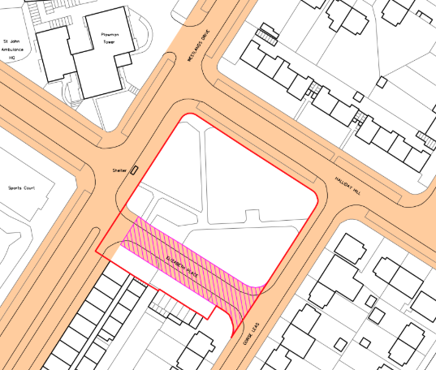
Plot plan:
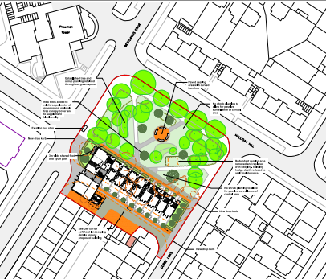
- The scheme was granted planning consent subject to s106 at planning committee in June 2023 (22/01554/FUL). The s106 agreement is now signed.
- The homes are designed to a high quality, exceeding a 40 per cent reduction in carbon emissions (against 2022 building standards). The scheme uses a fabric-first approach to minimise energy consumption and cost, with a target of zero carbon for regulated energy. An all-electric scheme is expected to achieve this, with air-source heat pumps and PV panels on roofs. An EPC rating of B or above is expected.
- This is a low car development as it is close to public transport services and located in a Controlled Parking Zone (CPZ)

Alternative Options Considered
- There are no further alternatives to the proposed options, other than to not progress with the scheme.

Financial implications
- This report seeks the required delegations to further develop this scheme within the programme of affordable housing supply. The Council’s Medium Term Finance Plan (MTFP), approved at Council on 13 February 2025, supports the 40-year HRA Business Plan, and makes provision for purchases of affordable housing from OCHL’s 10-year development programme within an overall budget envelope of £332m (before grant and shared ownership sales). The budget includes a further £100m for direct delivery by the Council (in the HRA).
- The decision to proceed with any development or buy-back will be supported by a development scheme appraisal/ financial modelling to ensure that financial parameters and requirements are met for OCHL and the HRA. These parameters have been previously agreed and for the HRA are as follows for each scheme:
- a payback period of up to 70 years; and
- a positive Net Present Value (NPV) over this period; and
- an Internal Rate of Return (IRR) of at least 3%.
- Meeting these parameters ensures that the HRA business plan remains financially robust. Conversely, not meeting these parameters will impact this position.

Legal issues
- Under Parts, (9), (10) and (11) of the Constitution, Cabinet is responsible for the decisions set out in the recommendation. Cabinet is empowered to agree transfers between cost centres of over £250,000 provided that they are consistent with the policy framework, give project approval for projects of £750,000 or over and award contracts over £750,000. Under section 9E (3) (c) of the Local Government Act 2000 Cabinet is empowered to delegate its functions to officers and therefore is permitted to delegate authority to the Director of Housing, in consultation with relevant officers to enter into build contracts and any ancillary legal documents to facilitate the development.
- In accordance with Part 4.4 of the Constitution, a delegated officer is empowered to award a contract with a value in excess of £10,000 but less than £750,000 when the Council is the buyer.
- In accordance with Part 19.12 of the Constitution the council may commission it’s Teckal companies for one off capital schemes or services The Teckal company benefit from the “Teckal” exemption to the procurement legislation. This means that the council may award contracts to a teckel company without the need to comply with procurement law but it must comply with the Council’s contract rules, specifically Part19 Appendix 2 of the Constitution
- Procurement of goods and services for the purpose of developing homes must be carried out in accordance with the Council’s Constitution, Contract Rules, procurement procedures and in compliance with the Procurement Act 2023 (or any successor legislation), including adherence to transparency, fairness and best value principles.
- The proposals set out in this report fall within Council’s statutory powers including the power to provide and manage housing through the Housing Revenue Account (HRA). The general power of competence under the Localism Act 2011 and the Local Authorities (Land) Act 1963 enables the Council to develop land it already owns. These powers support both direct delivery by the Council or acquisition from its wholly owned company (OCHL).
- The Council will need to enter into construction and consultancy contracts directly for this development, as well as agreeing a Development Services Agreement with OCHL. Such agreements must be carefully structured to comply with procurement law, avoid unlawful subsidy, and protect the Council's financial and delivery interests.

Level of risk
- Any risks inherent in this programme are already identified elsewhere, with actions to mitigate these detailed in the OCHL and HRA Business Plans and the Council’s Medium Term Financial Plan.
- The risks include potential cost overruns or visibility, and legal exposure if contracts are not appropriately structured. These risks will be mitigated through detailed financial appraisals, use of established governance delegations, and legal oversight throughout procurement and contracting stages.

Equalities impact
- There are no adverse impacts in undertaking this activity, with the potential to improve provision for persons in housing need, through the provision of more affordable and accessible housing to better meet client needs.
Carbon and Environmental Considerations
- All development schemes delivered by the Council / OCHL are subject to high sustainability standards with the expectation that they exceed statutory (building) standards.

Report author | Dave Scholes
Job title | Affordable Housing Supply Corporate Lead
Service area or department | Regeneration, Economy and Sustainability
Telephone | 01865 252636
e-mail | dscholes@oxford.gov.uk

